**MANUAL FOR CONFIGURING THE PC IN**

**ORDER TO**

**CCEPT THE SECURITY CERTIFICATE**

**( ALM -INCIDENCE-160 )**

You must follow these steps to accept the security certificate on the pc.

* We access the page with the security certificate:

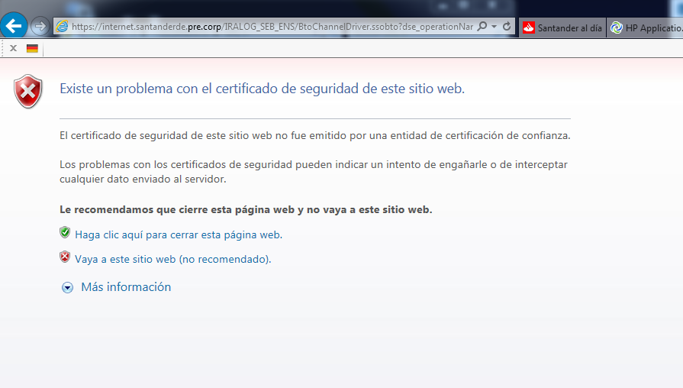

* Click on: “ Go to this website(not recommended)”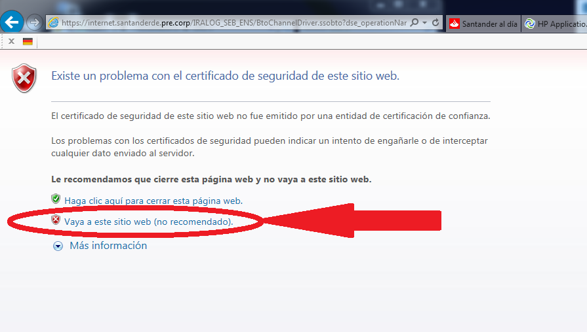
* It shows the following screen:

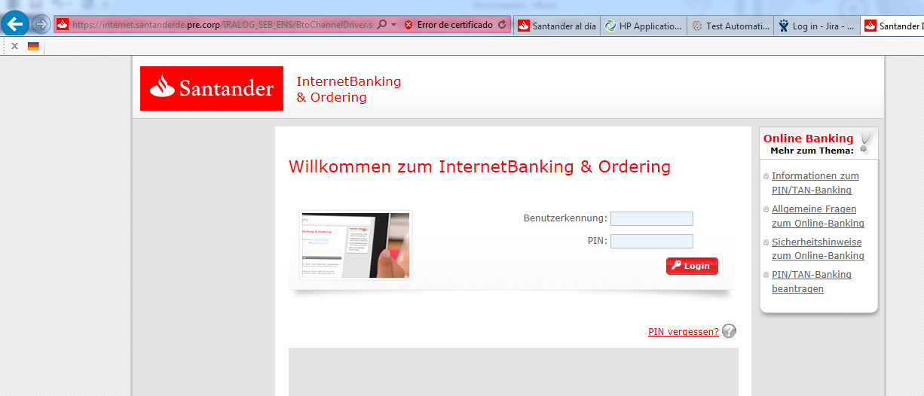

* Click on “Certificate Error”

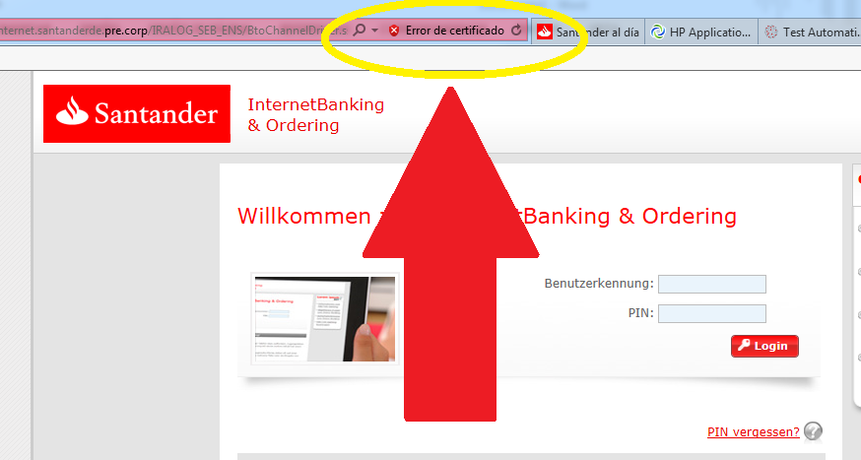

* The following screen appears:

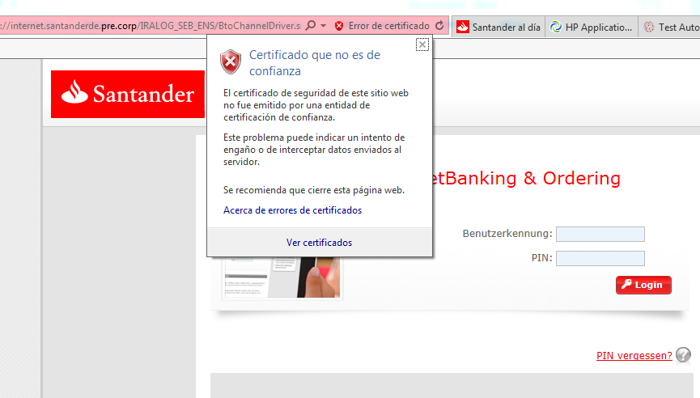

* And we click on “ View certificates”

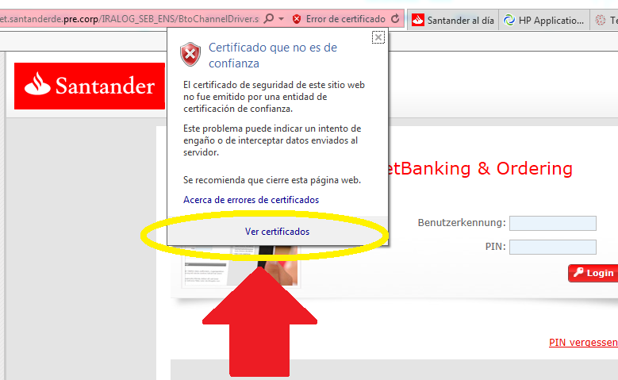

* The following screen opens:

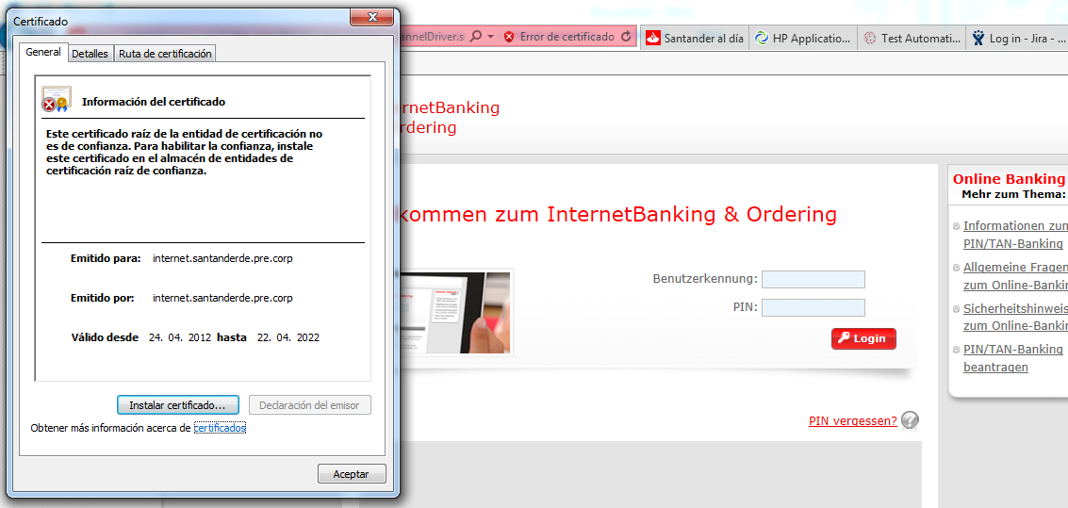

* Click on “Install Certificated”

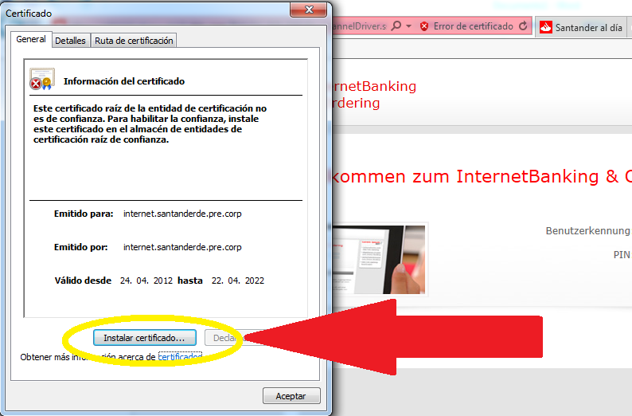

* It appears the screen:

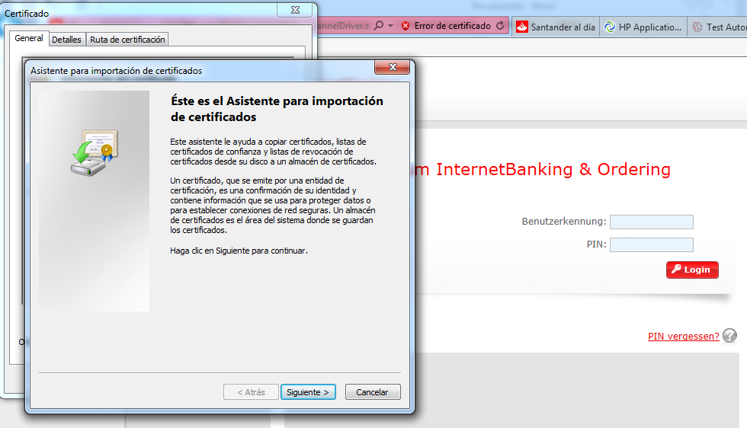

* Next step is to click on”Next”:

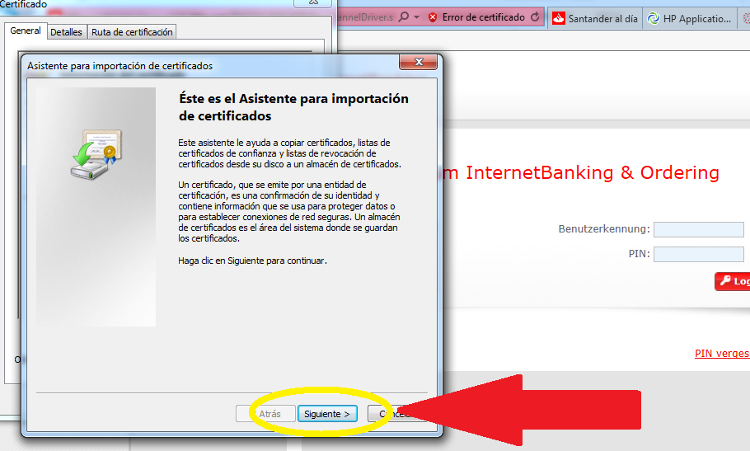

* It appears:

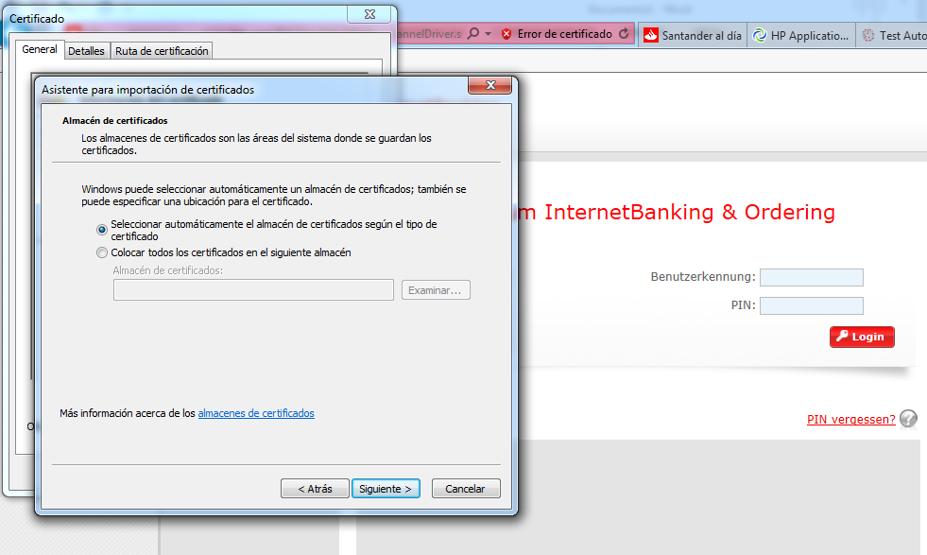

* Click on “next” again:

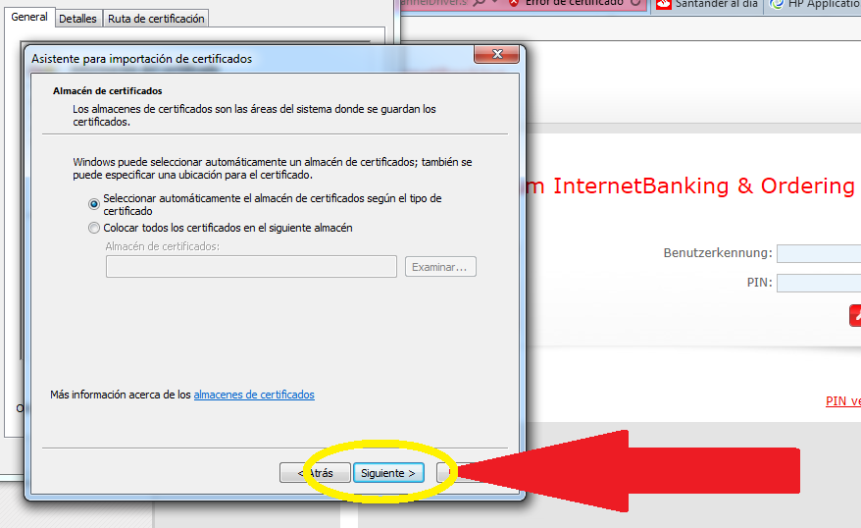

* This screen appears with “Certificate Store Selected” selected:

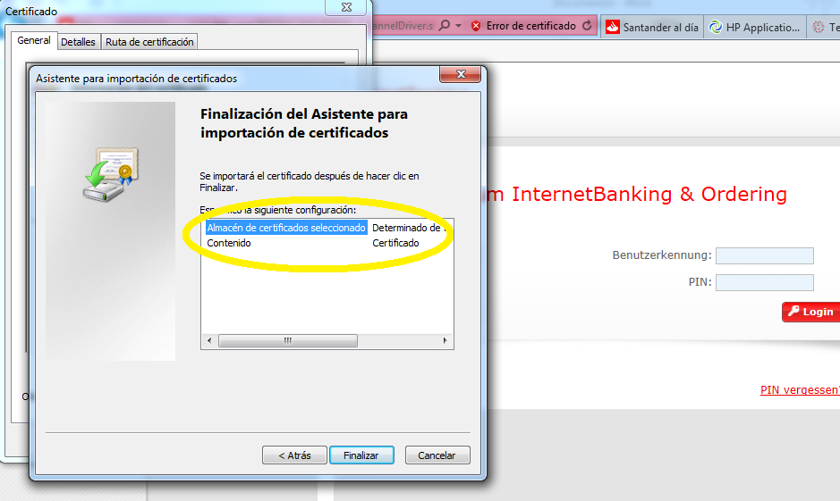

* Click on “Finish”:

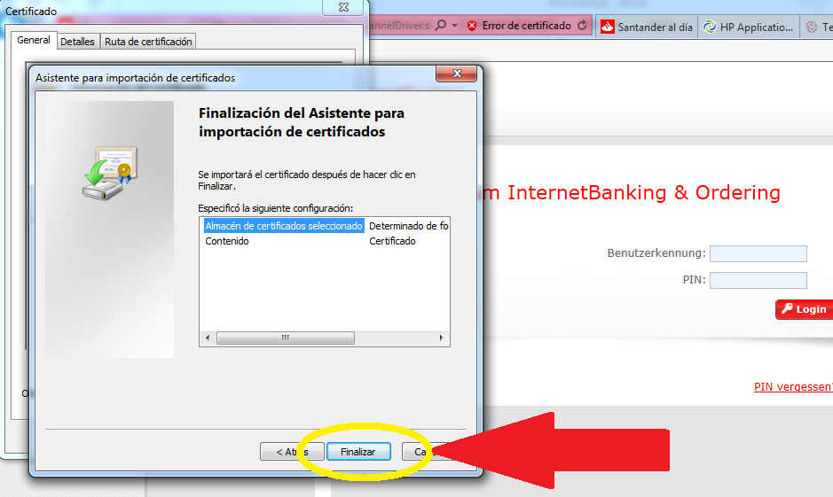

* It appears:

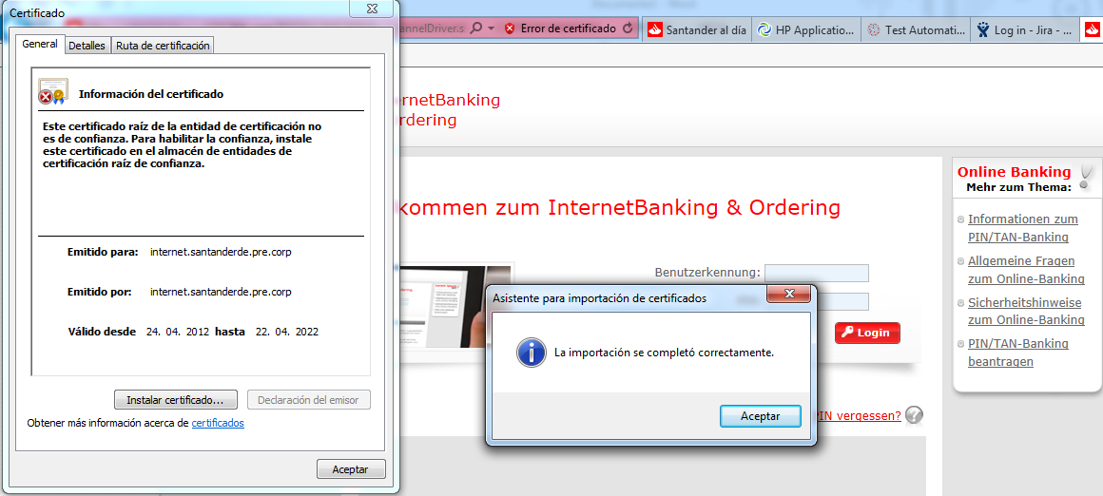

* The import was successful, and click on “OK”

