

DOCUMENTATION
“TAST Selective Mapping”
[SIPSA]

1.Index
1.Index 2
2.Introduction 3
3. Set up of Selective Mapping 4
4. To work with Selective Mapping 8
5. Considerations about using Selective Mapping 10
6. Workaround to work with Selective Mapping for applications with deprecated technologies 12

2.Introduction
This document aims to describe the features of the Selective Mapping functionality in TAST application.

3. Set up of Selective Mapping
- In the browser, open the TAST tool.
- Add this page to Favorites Bar:
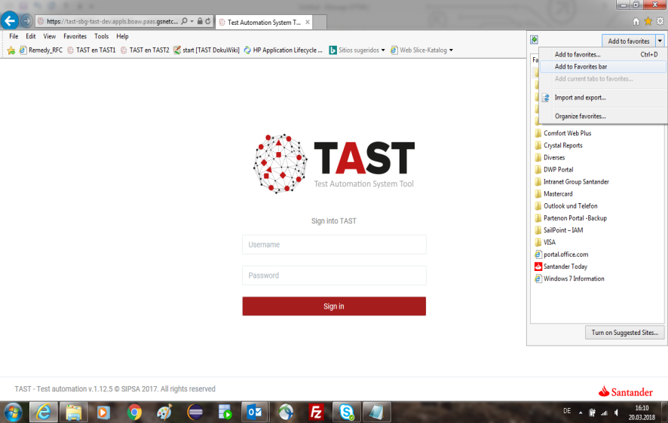

- Rename this favorite to ‘Selective Mapping’:
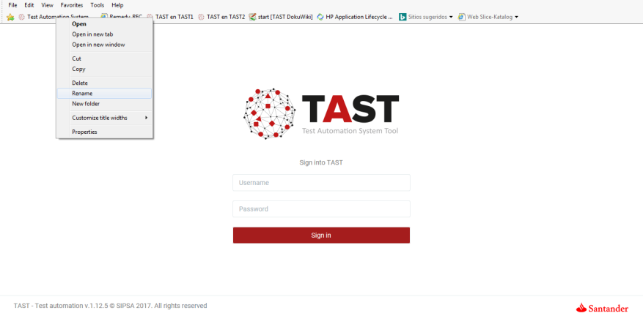

!!!!!!!!!!!!!!! PANTALLA !!!!!!!!!!!!!!!!!!!!!!!

- Make visible Selective Mapping in the browser's favourite bar:
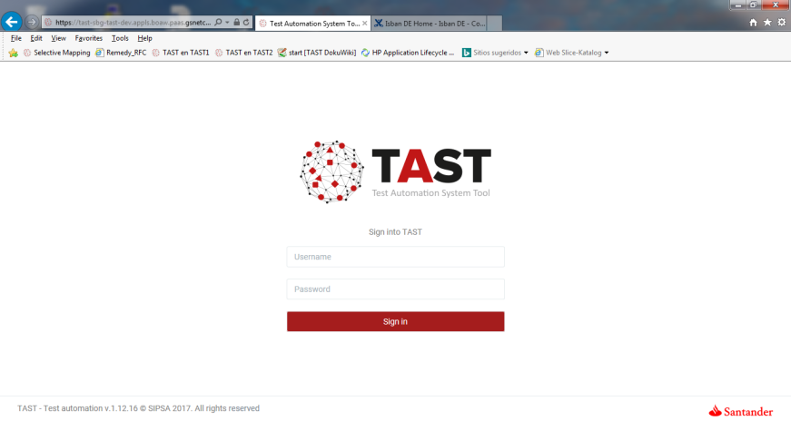

- Positioned in Selective Mapping, right mouse button, and select Properties:
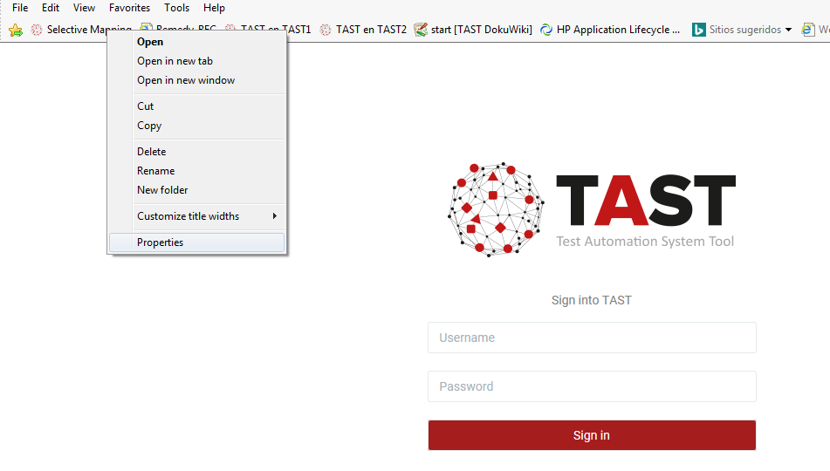

- Copy the following text in the URL:
javascript:prefFile='';void(z=document.body.appendChild(document.createElement('script')));void(z.language='javascript');void(z.type='text/javascript');void(z.src='https://tast-sbg-tast-dev.appls.boaw.paas.gsnetcloud.corp/selectivemapping');void(z.id='tast');
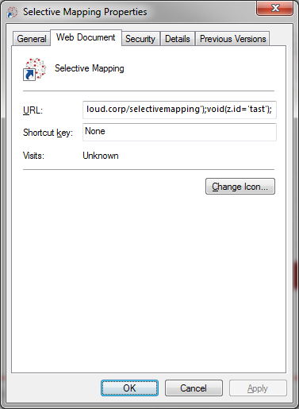

- After clicking on the Selective Mapping favorite, appears a window similar to the following:
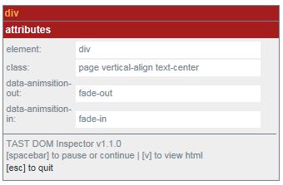

- The attributes will change depending on where the focus is in the web page.

4. To work with Selective Mapping
- In the browser, open the Selective Mapping favorite.
- In TAST tool, in the Modeling option, open your diagram, and select the magic wand icon (Selective mapping):
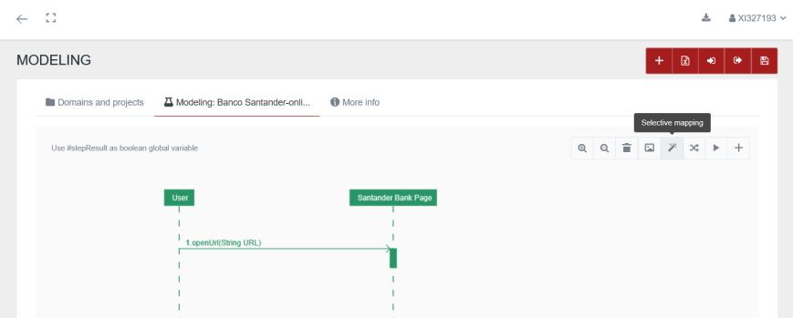

- This TAST option launches the browser with the URL defined in the GUI adaptor in a new window:
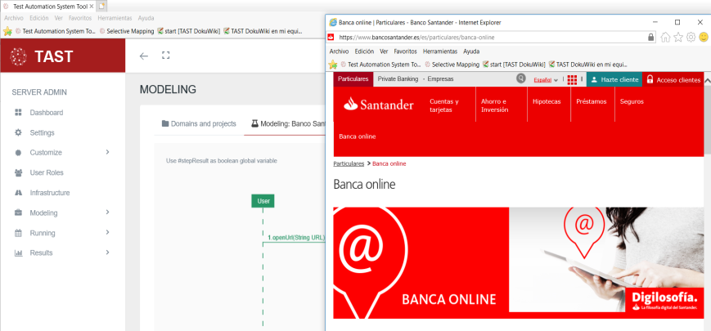

- In this moment, by clicking on the favorite Selective Mapping, we can work with the selective mapping (putting mouse over any element):
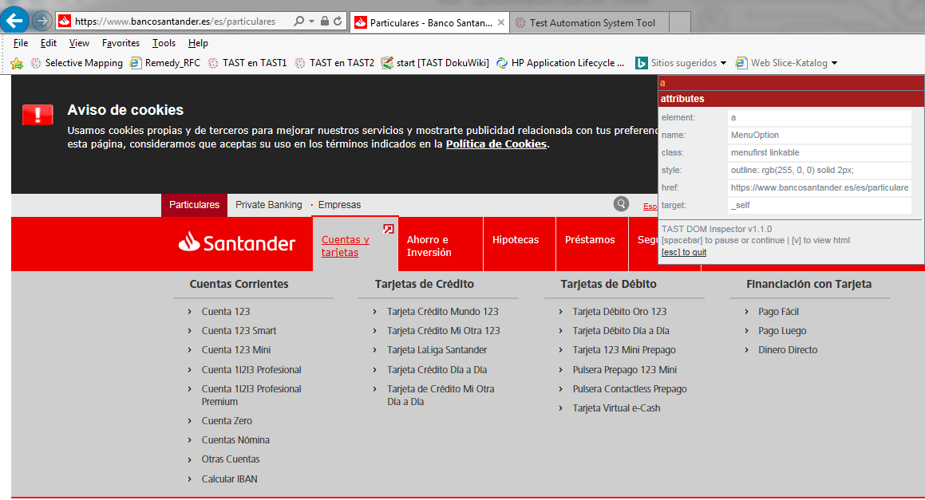

- The available options for the Selective Mapping functionality are:
  - To pause or continue using Selective Mapping: <Spacebar>
  - To copy the content of the attribute or search by: <Click + Control + C> (in Isban Pc´s use <Control + C>)
  - To paste the content of the attribute or search by: <Click + Control + V> (in Isban Pc´s use <Control + V>)
  - To view html source: [v]
  - To quit: [esc]

5. Considerations about using Selective Mapping
- When using Selective Mapping, the best search options are suggested from top to the bottom: first option the best search is by id (if it exists and no duplicate id´s has been detected), next by css, xpath etc ...
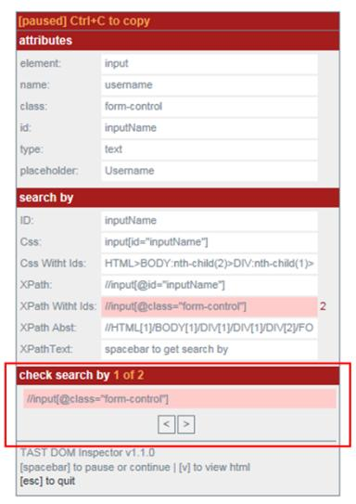
- When Selective Mapping is paused, there is the possibility to search for an item directly by XPath or CSS, being able to move element by element with the keys ‘<’ and ‘>’ if there are several results:

- With the console opened (F12), if the focus is on it, in order to Selective Mapping works correctly on the page to be mapped, you have to click again on any place of that page.
Recommendation: to be aware of where is the focus and click on the window, if there are doubts.
- When using Selective Mapping in the navigation between pages, if you want to use Selective Mapping in another page you have to reopen the Selective Mapping window.
- In the cases in which information is loaded using Ajax (for example, in a table, when this table is loaded when clicking), in the Selective Mapping window the information is not being refreshed.
To update the information in the Selective Mapping window, this must be restarted.
- Cross-domain: if on a page there are iframes from pages of different domain, the Selective Mapping will not work. It will work if the pages of the iframes are from the same domain.
- When are found duplicate ID´s of the element, the background of the ID field will appear in red. In these cases, it´s not recommended to use this type of search.
- When the Selective Mapping tool cannot check the css or xpath generated, the background of the ID field will appear in yellow.
- The user can use the “Check Search By” field only to search elements with the options in the “Search By” table above.
- The Search with ClassName just works with one class, for example if the ClassName result is “section interest-section” there are 2 classes, and the user should search only the class “section” or the class “interest-section”

6. Workaround to work with Selective Mapping for applications with deprecated technologies
- For these applications it may be more difficult to use the Selective Mapping.
- In these cases, there is a workaround to follow:
  - In the popup window, open the console with F12.
  - In the bar under the console, copy the script that runs from Selective Mapping favourite:
javascript: prefFile = ''; void (z = document.body.appendChild (document.createElement ('script'))); void (z.language = 'javascript'); void (z.type = 'text / javascript' ); void (z.src = 'https: //tast-sbg-tast-dev.appls.boaw.paas.gsnetcloud.corp/selectivemapping'); void (z.id = 'tast');
  - Click on the green button 'play'.
  - Click anywhere in the principal application window to return the mouse focus from F12.
